2019 Sponsor Letter Form
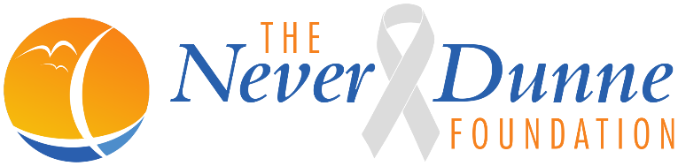
17 Fairport Avenue
Narragansett, RI 02882
michele@theneverdunnefoundation.com
www.theneverdunnefoundation.com
Tax ID: 83-3746483
Dear Potential Sponsor / Local Business Owner:
The Never Dunne Foundation was established in 2018 in loving memory of Scott Dunne who passed away from Glioblastoma Brain Cancer. This devastating type of brain cancer, has been in the news recently with Senator John McCain’s recent passing as well. Glioblastoma is notoriously aggressive, growing rapidly and often defying treatment with surgery, radiation and chemotherapy. By most estimates, half of the patients with this diagnosis will succumb to it within 15 to 18 months, and only 5 or 10 percent will be living in five years.
Our Foundation has been created to financially help families affected by this disease and give them the ability to make memories while they still can. The Foundation will also assist families and caregivers with the financial ability to care for their loved one in their final stages. However, we cannot help those affected without the help and support of our community. We would like to add your business to the list of supporters. All supporters will be added to the list of sponsors on our website www.theneverdunnefoundation.com .

Sponsorship Opportunities
$500.00 Sponsorship
  - Inclusion of coupons / promotional items at sponsored event
  - Company Name on foundation website under Sponsor Listing with link to company website
  - Company advertisement on Social Media for sponsored event
  - Premium Location of Company Logo listed on promotional banners or signage for the sponsored event
  - 2 Complimentary entries to sponsored event
$300.00 Sponsorship
  - Inclusion of coupons / promotional items at sponsored event
  - Company Name on Foundation website under Sponsor Listing
  - Company advertisement on Social Media for sponsored event
  - Company Logo listed on promotional banners or signage for the sponsored event
  - 1 Complimentary entry to sponsored event
$150.00 Sponsorship
  - Inclusion of coupons / promotional items at sponsored event
  - Company Name on foundation website under Sponsor Listing
  - Company Logo listed on promotional banners or signage for the sponsored event

Other ways to help:
  - Gift Certificate for company to be used at fundraiser ________________________________________
  - Donation of Service or goods for a fundraising event: ________________________________________
  - Donation of time for a fundraising event: __________________________________________________
  - Monitory donation in the amount of: $ __________________________
Please make checks payable to The Never Dunne Foundation

